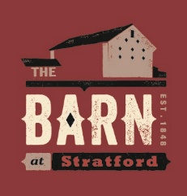
BRINGING HISTORY TO LIFE
Join us for these programs in 2026!

Programs are free unless otherwise noted. Members receive a discount for ticketed events.
All programs are held at The Barn at Stratford, unless otherwise noted. *
The Barn at Stratford
2690 Stratford Road
Delaware, OH 43015

Email:
programs@DelawareOhioHistory.org
Website: www.DelawareOhioHistory.org
Phone:
740-369-3831(Voicemail)

How Ohio Won the Civil War
WHEN: Thursday, August 18, at 7:00 PM
WHO: Presented by Michael Wise, President,
Big Walnut Area Historical Society
The History of Fairs in Delaware County
WHEN: Tuesday, September 29, at 7:00 PM
WHO: Presented by Don Howard and Society Volunteers

Life with the Circus: Francis Beverly Kelley
WHEN: Tuesday, October 20, at 7:00 PM
WHO: Presented by Society Volunteer Mike Hoffman
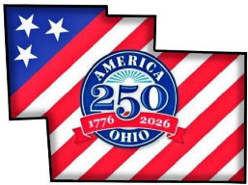
Annual Meeting - Celebrating Delaware and Delaware County First Responders
WHEN: Thursday, November 19, at 7:00 PM
WHO: Panel discussion with representatives from law enforcement, fire, and emergency medical.

Holiday Trolley Tour
WHEN: Saturday, December 12, Noon-6:00 PM
WHO: Hosted by Society Volunteer Benny Shou

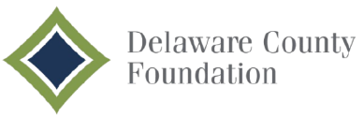
Registration is on Eventbrite
for all programs and events.

https://www.eventbrite.com/d/oh--delaware/delaware-county-historical-society/

Registrants can sign up to watch the live stream program via a YouTube link, for a small fee charged on Eventbrite, when available.

Additional information will be posted on our website several weeks before each event:
https://www.DelawareOhioHistory.org/programs-and-events/
Audio-visual equipment and internet access provided through a grant from the Delaware County Foundation.

